

**JON KEEN, DEPUTY COO**

**(INTERIM) COMMISSIONER**

**MONIQUE FRANKLIN**

**Director, Administrative and Technical Services**

**C I T Y O F A T L A N T A**

**KEISHA LANCE BOTTOMS**

**MAYOR**

DEPARTMENT OF GRANTS AND COMMUNITY DEVELOPMENT

**55 TRINITY AVENUE, S.W. SUITE 3500 – ATLANTA, GEORGIA 30303**

**404-330-6390 - TDD : 404-658-7820**

**http://www.atlantaga.gov**

**To:** All HOPWA Staff and Project Sponsors

**From**: Lolita S. Collins, Grants Services Manager-Policy, Administrative and Technical Services

**Date**: June 19, 2020

**Subject**: National HIV Testing Day

**Cc**: Jon Keen, Chief Operating Officer, Deputy/Interim Commissioner, DGCD

Monique Franklin, Director, Administrative and Technical Services

Denise Zeigler, Assistant Grants Services Manager, Planning and Program Operations

Today, HIV.gov announced that National HIV Testing Day is June 27, 2020. This year's theme "Knowing" focuses on knowing’s one HIV status, recognizes new ways to take an HIV test, and reflects that we can continue the momentum toward *Ending the HIV Epidemic: A Plan for America*. This year self-testing is an option when facility-based services and in-person contact is limited. Please forward this announcement.

National HIV Testing Day (NHTD) was first observed on June 27, 1995. NHTD is a day to encourage people to [get tested for HIV](https://locator.hiv.gov/), know their status, and get linked to care and treatment.

For more information about testing day, please visit <https://www.hiv.gov/events/awareness-days/hiv-testing-day>. Also, use the search locator for testing services, housing providers, health centers and other service providers near your current location at https://locator.hiv.gov/

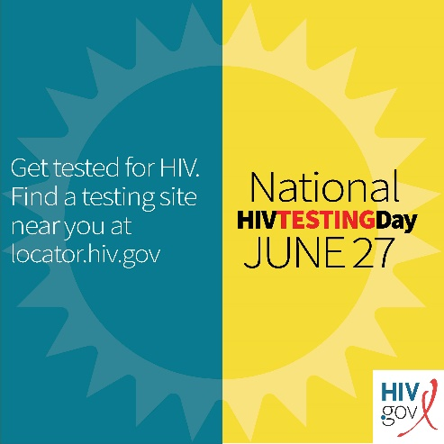

Cc:

December Thompson, Grants Services Manager-Fiscal, Planning and Program Operations Administrative and Technical Services

John Armour, Assistant Grants Services Manager, Planning and Program Operations