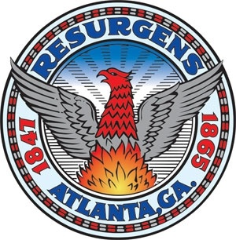 | City of Atlanta  Department of Grants and Community Development
 | Training Request Form
The Department of Grants and Community Development (DGCD) has a robust Technical Assistance and Outreach program. The program includes providing technical assistance, education and outreach throughout the City of Atlanta by conducting technical trainings and workshops in the areas of HUD formula programs and other regulatory compliance. The Office also hosts and participates in conferences, symposiums, and panels.
Complete the form below if you are interested in:
- Requesting our Training Services
- Requesting a Staff Member to attend an event
Name of your Agency/Organization

Agency Point of Contact (Name, Title, Email Address, Telephone Number)

What type of Training are you requesting?

Proposed Date/Time for the Training. Please provide 3 or more Proposed Dates with specific timeframes

Location / Address for the Training

What specific topic(s) would you like to be covered?

Who is the training audience?
City of Atlanta Employees. List Department/Office: ____________________________________
Senior Management, City Council Members, Managers & Supervisors
Agency Executives
General Public
Housing Providers
Realtors
Developers, CHDO’s, Non-Profit Entity, For-Profit Entity
Property Managers
Other: List __________________________________________

How many participants do you expect?

What is the level of experience of the training participates?
0-2 Years
3-5 Years
6- or more Years

Are there any special circumstances that DGCD should be aware of as we prepare for the training session or speaking engagement?

